Details on the Battle Effects and Event Space event Management

Basic Information
The first section that the Admin manages deals with some basic information regarding the Battle Effect or Event Space event.

Battle Effect or Event Space event?___________________________________________________
Here is where the Admin decides whether this effect will be a Battle Effect or an Event Space event.
If the Admin chooses Battle Effect, then this will be something that can only be triggered by a player during a sequence, or turn, in battle… in place of a Battle Roll.
If the Admin chooses Event Space event, then this will be something that is triggered by a player landing on an Event Space. It is selected at random from a list of Event Space events.

Effect Name_________________________________________________________________________
Here the Admin determines a name for the effect.
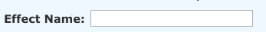
If this is a Battle Effect, then this name appears in the information for the effect in the Battle Effects Compendium. It is also displayed in the Action Box of all players when one of them chooses to use it.
If this is an Event Space event, then this description is displayed in the Action Box of all players when one of them lands on an Event Space.

Effect Description____________________________________________________________________
Here the Admin provides a description of how the effect will affect gameplay.
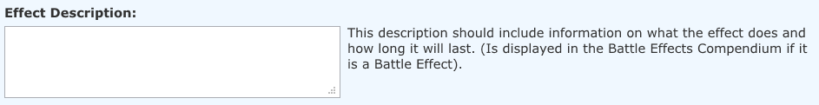
If this is a Battle Effect, then this description appears in the information for the effect in the Battle Effects Compendium. It is also displayed in the Action Box of all players when one of them chooses to use it.
If this is an Event Space event, then this description is displayed in the Action Box of all players when one of them lands on an Event Space.

Click Cost___________________________________________________________________________
Here the Admin will enter a numeric value that will represent how many “clicks” this (as a Battle Effect) will cost. This information also appears in the Battle Effects Compendium.
If this is an Event Space event, then the Admin would leave this blank, as it has no purpose with regard to Event Space events.

Attribute and Attribute Level Required________________________________________________
Here the Admin will determine which of the six (6) DigiChar Attributes and its corresponding Level (a numeric value between thirty (30) and one hundred and eighty (180)) that will be required for this (as a Battle Effect) to be effective. This information also appears in the Battle Effects Compendium.
If this is an Event Space event, then the Admin would leave this blank, as it has no purpose with regard to Event Space events.

Who Is Affected?____________________________________________________________________
Here the Admin will determine who will be affected by this Battle Effect or Event Space event… the player, or his opponent or opponents (from here on known as “the affected party”). This information also appears in the Battle Effects Compendium.
The Admin can choose one or both of these options.

Category___________________________________________________________________________
Here the Admin will decide how this Battle Effect or Event Space event will be categorized, based on its effect on gameplay.
There are three options to choose from:
- Movement
- Space Values
- Attack/Manipulate

Determining The Effects
The second section that the Admin manages is a selection of eight (8) “packages” (of which the Admin can choose ONLY one (1)) that determine what gameplay effects will result from the Battle Effect or Event Space event.

PACKAGE ONE (1)___________________________________________________________________
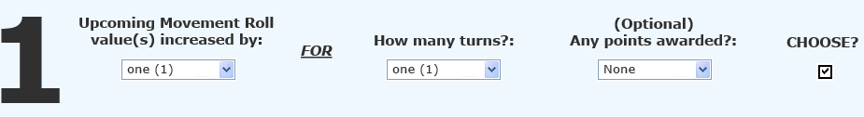
Upcoming Movement Roll value(s) increased by:
Here the Admin can choose an amount of spaces that will be added to the affected party’s NEXT Movement Roll (or Rolls, if more than one (1) turn is chosen in the next selection area). The selections are as follows:
- One (1) – (This will add one (1) extra space to the Movement Roll.)
- Two (2) – (This will add two (2) extra spaces to the Movement Roll.)
- Three (3) – (This will add three (3) extra spaces to the Movement Roll.)
- Four (4) - (This will add four (4) extra spaces to the Movement Roll.)
- Five (5) – (This will add five (5) extra spaces to the Movement Roll.)
- X by Two (2) - (This will double the amount of spaces to move that is determined by the Movement Roll.)

How many turns?:
Here the Admin will choose what amount of upcoming Movement Rolls will be affected by the previous selection. The selections are as follows:
- One (1) – (The effect will last for only one (1) of the affected party’s upcoming Movement Rolls.)
- Two (2) – (The effect will last for two (2) of the affected party’s upcoming Movement Rolls.)
- Three (3) – (The effect will last for three (3) of the affected party’s upcoming Movement Rolls.)
- Four (4) – (The effect will last for four (4) of the affected party’s upcoming Movement Rolls.)
- Five (5) – (The effect will last for five (5) of the affected party’s upcoming Movement Rolls.)
- Whole Game – (The effect will last for ALL of the affected party’s upcoming Movement Rolls, lasting until the end of the game).

(Optional) Any points awarded?:
Here the Admin can choose (or choose NOT to, by selecting “None”) an amount of points that are automatically added to OR subtracted from the affected party’s Point Total in the game when the effect determined in this “package” is triggered or used. The selections are as follows:
- None – (There is NO effect on the affected party’s Point Total).
- + One (1) Pt. – (One (1) point is added to the affected party’s Point Total).
- + Two (2) Pts. – (Two (2) points are added to the affected party’s Point Total).
- + Three (3) Pts. – (Three (3) points are added to the affected party’s Point Total).
- + Four (4) Pts. – (Four (4) points are added to the affected party’s Point Total).
- + Five (5) Pts. – (Five (5) points are added to the affected party’s Point Total).
- - One (1) Pt. – (One (1) point is subtracted from the affected party’s Point Total).
- - Two (2) Pts. – (Two (2) points are subtracted from the affected party’s Point Total).
- - Three (3) Pts. – (Three (3) points are subtracted from the affected party’s Point Total).
- - Four (4) Pts. – (Four (4) points are subtracted from the affected party’s Point Total).
- - Five (5) Pts. – (Five (5) points are subtracted from the affected party’s Point Total).
- Owned Spaces – (Whatever the current point value is of every Colony and Gold Colony Space that is owned by the affected party, that point value is added to the affected party’s Point Total).
- Owned Spaces N – (Whatever the current point value is of every Colony and Gold Colony Space that is owned by the affected party, that point value is subtracted from the affected party’s Point Total).

PACKAGE TWO (2)___________________________________________________________________
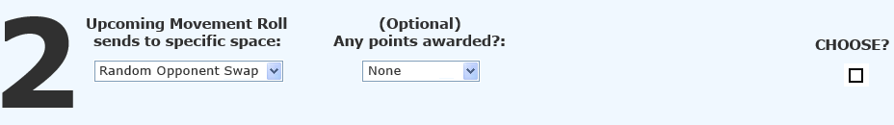
Upcoming Movement Roll sends to specific space:
Here the Admin can choose a specific space, or type of space, that the affected party’s NEXT Movement Roll sends them to (regardless of what amount is actually rolled).
The space that the affected party lands on will function as it normally would (For example, if the affected party’s token is sent to an opponent owned Colony Space, a battle begins, etc.) The selections are as follows:
- Random Player Swap – (The affected party’s token “swaps” spaces with a randomly selected opponent’s. If there is only one (1) opponent, the affected party’s token “swaps” spaces with that opponent’s).
- Next Colony Space – (The affected party’s token is sent to the nearest Colony Space (but NOT backwards/clockwise)).
- Next Gold Colony Space – (The affected party’s token is sent to the nearest Gold Colony Space (but NOT backwards/clockwise)).
- Next Event Space – (The affected party’s token is sent to the nearest Event Space (but NOT backwards/clockwise)).
- Ahead To Faction Space – (The affected party’s token is sent forward to their Faction Space. The points that will be added to the affected party’s Point Total as a result of landing on their Faction Space is determined by the next selection).
- Ahead One (1) Space – (The affected party’s token is sent forward one (1) space).
- Ahead Two (2) Spaces – (The affected party’s token is sent forward two (2) spaces).
- Ahead Three (3) Spaces – (The affected party’s token is sent forward three (3) spaces).
- Ahead Four (4) Spaces – (The affected party’s token is sent forward four (4) spaces).
- Ahead Five (5) Spaces – (The affected party’s token is sent forward five (5) spaces).

(Optional) Any points awarded?:
Here the Admin can choose (or choose NOT to, by selecting “None”) an amount of points that are automatically added to OR subtracted from the affected party’s Point Total in the game when the effect determined in this “package” is triggered or used. The selections are as follows:
(SAME AS PACKAGE ONE (1))

PACKAGE THREE (3)__________________________________________________________________
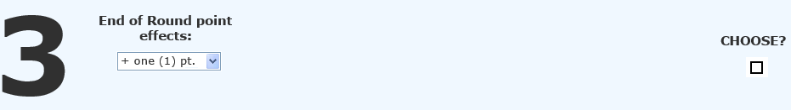
End of Round point effects:
Here the Admin can choose an amount of points that will be added to OR subtracted from the points that are earned by the affected party the NEXT time they land on or pass their Faction Space. The selections are as follows:
- + One (1) Pt. – (One (1) point is added to the affected party’s points earned).
- + Two (2) Pts. – (Two (2) points are added to the affected party’s points earned).
- + Three (3) Pts. – (Three (3) points are added to the affected party’s points earned).
- + Four (4) Pts. – (Four (4) points are added to the affected party’s points earned).
- + Five (5) Pts. – (Five (5) points are added to the affected party’s points earned).
- - One (1) Pt. – (One (1) point is subtracted from the affected party’s points earned).
- - Two (2) Pts. – (Two (2) points are subtracted from the affected party’s points earned).
- - Three (3) Pts. – (Three (3) points are subtracted from the affected party’s points earned).
- - Four (4) Pts. – (Four (4) points are subtracted from the affected party’s points earned).
- - Five (5) Pts. – (Five (5) points are subtracted from the affected party’s points earned).
- No Points Earned – (The affected party receives NO points the NEXT time they land on or pass their Faction Space)

PACKAGE FOUR (4)__________________________________________________________________
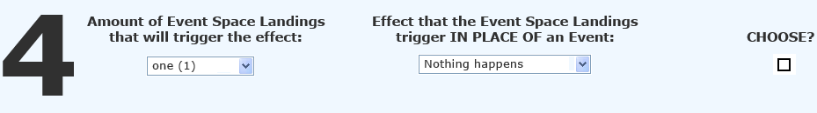
Amount of Event Space Landings that will trigger the effect:
Here the Admin can choose an amount of times that an affected party can land on an Event Space and have the “alternate” effect chosen in the next selection be triggered in place of a normal Event Space event. The selections are as follows:
- One (1) – (The NEXT time the affected party lands on an Event Space, the alternate effect is triggered).
- Two (2) – (The NEXT two (2) times the affected party lands on an Event Space, the alternate effect is triggered).
- Three (3) – (The NEXT three (3) times the affected party lands on an Event Space, the alternate effect is triggered).
- Four (4) – (The NEXT four (4) times the affected party lands on an Event Space, the alternate effect is triggered).
- Five (5) – (The NEXT five (5) times the affected party lands on an Event Space, the alternate effect is triggered).
- Whole Game – (EVERY time the affected party lands on an Event Space during the remainder of the game, the alternate effect is triggered).

Effect that the Event Space Landings trigger IN PLACE OF an Event:
Here the Admin must choose what effect will be triggered IN PLACE OF the normal Event Space events, when the affected party lands on an Event Space. The selections are as follows:
- Nothing Happens – (The affected party landing on an Event Space has no effect. The Event Space essentially acts like a Standard Space).
- + One (1) Pt. – (One (1) point is added to the affected party’s Point Total).
- + Two (2) Pts. – (Two (2) points are added to the affected party’s Point Total).
- + Three (3) Pts. – (Three (3) points are added to the affected party’s Point Total).
- + Four (4) Pts. – (Four (4) points are added to the affected party’s Point Total).
- + Five (5) Pts. – (Five (5) points are added to the affected party’s Point Total).
- - One (1) Pt. – (One (1) point is subtracted from the affected party’s Point Total).
- - Two (2) Pts. – (Two (2) points are subtracted from the affected party’s Point Total).
- - Three (3) Pts. – (Three (3) points are subtracted from the affected party’s Point Total).
- - Four (4) Pts. – (Four (4) points are subtracted from the affected party’s Point Total).
- - Five (5) Pts. – (Five (5) points are subtracted from the affected party’s Point Total).
- Owned Spaces – (Whatever the current point value is of every Colony and Gold Colony Space that is owned by the affected party, that point value is added to the affected party’s Point Total).
- Owned Spaces N – (Whatever the current point value is of every Colony and Gold Colony Space that is owned by the affected party, that point value is subtracted from the affected party’s Point Total).

PACKAGE FIVE (5)___________________________________________________________________
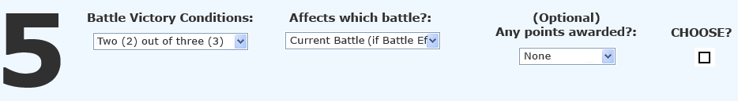
Battle Victory Conditions:
Here the Admin can choose to place certain conditions on achieving victory in a battle. A battle cannot be won unless the affected party achieves the condition set here. The selections are as follows:
- Two (2) out of Three (3) – (The affected party must win two (2) battles in order to be victorious).
- Three (3) out of Five (5) – (The affected party must win three (3) battles in order to be victorious).
- Auto Win Battle – (The affected party automatically wins one (1) battle).
- Auto Win ALL Battles – (The affected party automatically wins ALL battles for the remainder of the game).
- Auto Lose Battle – (The affected party automatically loses one (1) battle).
- Auto Lose ALL Battles – (The affected party automatically loses ALL battles for the remainder of the game.)

Affects which battle?:
Here the Admin must determine whether or not any currently ongoing battle can be affected by this effect (IF this effect is a Battle Effect, and NOT an Event Space event. IF this is an Event Space event, the selection chosen here CANNOT include “Current Battle (if Battle Effect)”. The selections are as follows:
- Current Battle (if Battle Effect) – (IF this is a Battle Effect, this selection will allow the affected party to use it AND be governed by it during the current battle they are in).
- Next Battle – (The affected party will be governed by the Battle Victory Conditions beginning at their NEXT battle).

(Optional) Any points awarded?:
Here the Admin can choose (or choose NOT to, by selecting “None”) an amount of points that are automatically added to OR subtracted from the affected party’s Point Total in the game when the effect determined in this “package” is triggered or used. The selections are as follows:
(SAME AS PACKAGE ONE (1))

PACKAGE SIX (6)____________________________________________________________________
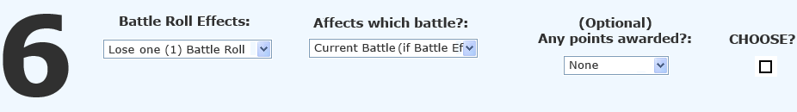
Battle Roll Effects:
Here the Admin can choose to set up an effect that manipulates the affected party’s upcoming Battle Rolls during a battle. The selections are as follows:
- Lose one (1) Battle Roll – (The affected party loses one (1) Battle Roll).
- Lose two (2) Battle Rolls – (The affected party loses two (2) Battle Rolls).
- Auto Success Battle Roll – (The affected party’s NEXT Battle Roll will automatically result in a successful “strike”).
- Auto Success two (2) Battle Rolls – (The affected party’s NEXT two (2) Battle Rolls will automatically result in successful “strikes”).

Affects which battle?:
Here the Admin must determine whether or not any currently ongoing battle can be affected by this effect (IF this effect is a Battle Effect, and NOT an Event Space event. IF this is an Event Space event, the selection chosen here CANNOT include “Current Battle (if Battle Effect)”. The selections are as follows:
SAME AS PACKAGE FIVE (5))

(Optional) Any points awarded?:
Here the Admin can choose (or choose NOT to, by selecting “None”) an amount of points that are automatically added to OR subtracted from the affected party’s Point Total in the game when the effect determined in this “package” is triggered or used. The selections are as follows:
(SAME AS PACKAGE ONE (1))

PACKAGE SEVEN (7)_________________________________________________________________
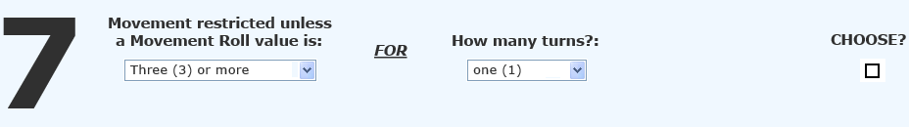
Movement restricted unless a Movement Roll value is:
Here the Admin can select a Movement Roll value that the affected party must roll an amount equal to or more than in order to successfully leave the space they are currently on. Movement Rolls of a value less than what is determined here, result in no movement for the affected party. The selections are as follows:
- Three (3) or more – (The affected party must complete a Movement Roll of three (3) or more in order for the Movement Roll to be successful).
- Four (4) or more – (The affected party must complete a Movement Roll of four (4) or more in order for the Movement Roll to be successful).
- Five (5) or more – (The affected party must complete a Movement Roll of five (5) or more in order for the Movement Roll to be successful).
- Six (6) – (The affected party must complete a Movement Roll of six (6) in order for the Movement Roll to be successful).

How many turns?:
Here the Admin will choose what amount of upcoming Movement Rolls will be affected by the previous selection. The selections are as follows:
(SAME AS PACKAGE ONE (1))

PACKAGE EIGHT (8)__________________________________________________________________
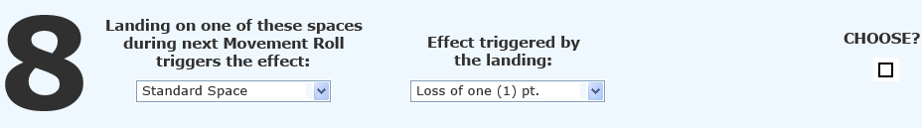
Landing on one of these spaces during next Movement Roll triggers the effect:
Here the Admin can choose a type of space that, if landed on by the affected party during their next turn, will trigger the effect chosen in the second parameter. Any effect that would normally occur as a result of landing on the space is replaced by this effect – For example: Event Space events, Colony Space ownership or battles for Colony Spaces, etc. are replaced by the chosen effect in the next parameter. The selections are as follows:
- Standard Space – (If the affected party lands on a Standard Space, the effect is triggered).
- Event Space – (If the affected party lands on an Event Space, the effect is triggered).
- Faction Space – (If the affected party lands on a Faction Space, the effect is triggered).
- Colony Space – (If the affected party lands on a Colony Space, the effect is triggered).
- Gold Colony Space – (If the affected party lands on a Gold Colony Space, the effect is triggered).

Effect triggered by the landing:
Here the Admin will determine which effect will be triggered by the affected party landing on the space type chosen. The selections are as follows:
- Random Event Space Event – (The affected party landing on the space triggers a randomly selected Event Space Event).
- Lose All Colony Spaces – (The affected party loses ownership of all owned Colony Spaces).
- Lose All Owned Spaces – (The affected party loses ownership of all owned Colony Spaces and Gold Colony Spaces).
- Gain All Colony Spaces – (The affected party gains ownership of all Colony Spaces on the Game Board).
- Lose Next Movement Roll – (The affected party loses their NEXT Movement Roll).
- Lose Next Two (2) Movement Rolls – (The affected party loses their NEXT two (2) Movement Rolls).
- Lose Next Three (3) Movement Rolls – (The affected party loses their NEXT three (3) Movement Rolls).
- + One (1) Pt. – (One (1) point is added to the affected party’s Point Total).
- + Two (2) Pts. – (Two (2) points are added to the affected party’s Point Total).
- + Three (3) Pts. – (Three (3) points are added to the affected party’s Point Total).
- + Four (4) Pts. – (Four (4) points are added to the affected party’s Point Total).
- + Five (5) Pts. – (Five (5) points are added to the affected party’s Point Total).
- + Ten (10) Pts. – (Ten (10) points are added to the affected party’s Point Total).
- - One (1) Pt. – (One (1) point is subtracted from the affected party’s Point Total).
- - Two (2) Pts. – (Two (2) points are subtracted from the affected party’s Point Total).
- - Three (3) Pts. – (Three (3) points are subtracted from the affected party’s Point Total).
- - Four (4) Pts. – (Four (4) points are subtracted from the affected party’s Point Total).
- - Five (5) Pts. – (Five (5) points are subtracted from the affected party’s Point Total).
- Owned Spaces – (Whatever the current point value is of every Colony and Gold Colony Space that is owned by the affected party, that point value is added to the affected party’s Point Total).
Owned Spaces N – (Whatever the current point value is of every Colony and Gold Colony Space that is owned by the affected party, that point value is subtracted from the affected party’s Point Total).

